Program-Code Editor Design

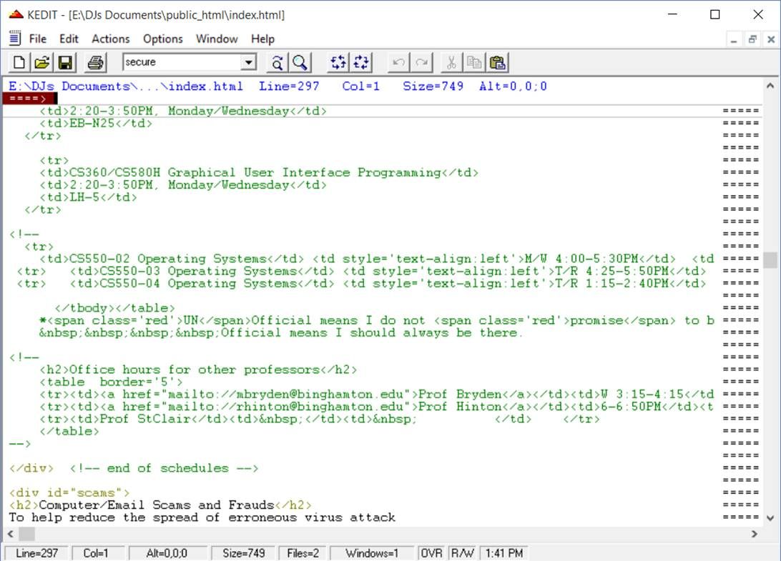This project is about text-editor and the program I will write will have the view like the picture below.

This picture is an example what I will do.

In the project, I am supposed to make some functionalities in such as save, save as, open button to open the desired file from the memory(this will be just in the menu command), help button opening a window with a list of commands and their usage which are sliders for left, right, up and down to see other parts of the window, scrolling end of the file or top of the file again to see the other parts of the file, #setcl function to show in which line user is, and it is needed to change when user uses scrolling or clicks the new line, change button to change string in line # to desired string that user entered, this button will also allow user to enter how many times user wants to change in per line, split button for allowing user split the window according to user choice like splitting horizontally or vertically, unsplit button to allow user to fill the window with just one selected file (This will be by removing undesired file).

I mean, there are just 4 buttons at the top of the page in the File button, as a menu bar which are save, save as, open, help. When user clicks on the help button, it will show the dropdown menu will have different options for users, which are sliders, scrolling, setcolumn, change, split, unsplit, to show what their usage are. These functionalities will be used in command line or as a button in the page. And also, there will be search area to allow user to search for a string in the file.

When user scrolls the window forward or backward, the window will show the last or the first line from the past window and new lines in the window according the choice.

All buttons except open will be usable in the command line or menu bar. In the top of the page, user will be able to see in which line user in.

User can enter upper case, lower case or mixed case to the command line.

File editing area should show suffix column denoted by the = = = = rows), a top of the file/end of the file indicator line, a split view indicator line, a hidden rows indicator line.

User will be also available to enter suffix commands to the command line such as i#(to insert lines), x#(to exclude # lines), s#(to show # lines), a(insert after this line), b(to insert before this line), c#(to copy # lines), m#(move # lines), “#(to duplicate # line). (Default of # is always 1)

Wiev

🡪Line number

🡪File, Help

Help🡪 …

File🡪 save, save as, open

🡪Toolbar icons

🡪Window for a command line

🡪 File editing area